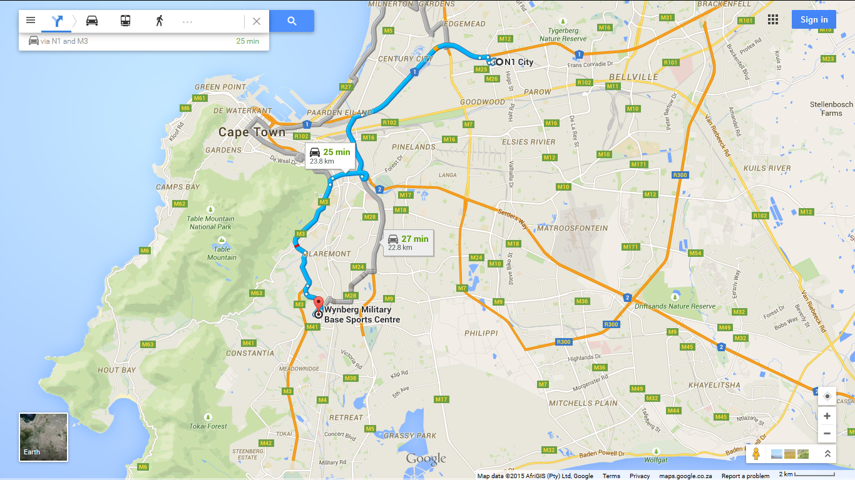
Continue on N1. Take M5 to Paradise Rd/M3 in Newlands
Merge onto N1 7.5 km
Take the M5 exit toward Maitland 90 m
Keep right at the fork and merge onto M5 3.6 km
Take exit 9B to merge onto Settlers Way/N2 toward Cape Town 2.3 km
Take exit 6 for Rhodes Drive toward M3/Observatory/Muizenberg 400 m
Merge onto M3 4.3 km

Continue on M3. Take Waterloo Rd to Camp Rd in Wynberg
Keep right to continue on Paradise Rd/M3 Continue to follow M3 1.9 km
Take the Trovato Link ramp to M155/Wynberg 500 m
Continue onto Trovato Link 550 m
Continue onto Waterloo Rd 700 m
Turn right onto Jan Smuts Rd Restricted usage road 400 m
Jan Smuts Rd turns left and becomes Camp Rd Restricted usage road
Destination will be on the left 82 m

GPS Coordinates
-34.007655, 18.461157

